**Report -> for Physical Training Labs**

Contents

Digital tool ASIC flow 1

How to talk computer 1

Open-source digital ASIC Flow 2

RTL to GDS Flow 2

Open Lane flow 2

Synthesis 3

Floor Planning 4

Placement 5

Open layout for one standrad cell and clone it . 6

Run extraction 7

Run SPICE 7

Calculate rise transition and fall transitions from waveforms 8

Creating LEF 8

# Digital tool ASIC flow

## How to talk computer

## Open-source digital ASIC Flow

## RTL to GDS Flow

## Open Lane flow

Design Name: picorv32a:

/home/kunalg123/Desktop/work/tools/openlane_working_dir/pdks/sky130A/libs.ref/sky130_fd_sc_hd

Directory presents inside this:

cdl doc gds lef lib mag maglef spice techlef Verilog

**Design Preparation:**

Example for config.tcl

**Command to preparation data:**

./flow.tcl -interactive

prep -design picorv32a : merging the LEF

## Synthesis

**Command used -> Run_synthesis**

**Results:**

Summary of synthesis and Flop ratio =10%

Files created after synthesis.



.v file and mapping has been done in synthesis stage:

Report files:

nawal.kishor@ansys-pd-workshop-01:~/Desktop/work/tools/openlane_working_dir/openlane/designs/picorv32a/runs/24-06_11-06/reports/synthesis$ ls

1-yosys_4.chk.rpt 1-yosys_dff.stat 2-opensta.min_max.rpt 2-opensta.slew.rpt 2-opensta_tns.rpt

1-yosys_4.stat.rpt 1-yosys_pre.stat 2-opensta.rpt 2-opensta.timing.rpt 2-opensta_wns.rpt

## Floor Planning

Inside README file there is all command are given for all stages and set parameters based on that.  
**

Priorities for the config files. Default config -> design config.tcl -> hdk .config.tcl

**Results file:**



Layout seen:

Open Layout in magic and query inside the GUI:

Standard cell placed at the lower side of the LEF.

Can change the floorplan and any stage by changing the variable:

## Placement

Command used for to open layout in magic :



GUI design after placement: Standard cells are placed and without DRC rule checks.

## Open layout for one standrad cell and clone it .

See the connections and cell layout after deleting the Geoms:

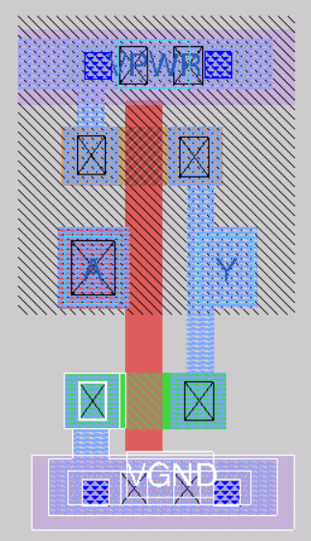

## Run extraction

## Run SPICE

Command: extspice

## Calculate rise transition and fall transitions from waveforms

**Rise transition: 0.5e-09 similarly can calculate the fall transition**

x0 = 2.23704e-09, y0 = 2.60161

x0 = 2.18134e-09, y0 = 0.659574

## Creating LEF

created the LEF file command used : lef write   
/home/nawal.kishor/Desktop/work/tools/openlane_working_dir/openlane/vsdstdcelldesign/sky130_vsdinv.lef